Temasek Polytechnic
School of Informatics and IT

Diploma in Information Technology (IT)

Software Design Specifications (SDS)

Project Particulars

Tutor | Mel Goh
Class | P03
Project Title | Delonix Regia Hotel Management System

Project Team’s Particulars

Matric Number | Student Name
1500880H | Edwin Poh Yi Han
1506191D | Chin Jun Jie
1507096D | Shen XingChen
1506034F | Adarsh Anilkimar Nair

Revision History

Date | Version | Description | Author
22/5/17 | 1.0 | Software Design Specifications to implement a hotel management system for Delonix Regia | Edwin, Jun Jie, Xing Chen, Adarsh

Table of Contents

1. DISTRIBUTION OF WORKLOAD 4
2. ARCHITECTURE DESIGN 4
3. USER INTERFACE (UI) DESIGN 6
4. PROGRAM DESIGN 14
5. DATABASE DESIGN 15

DISTRIBUTION OF WORKLOAD

Design | Members
User Interface (UI) design,  Program design: Domain class model, Database design | Edwin Poh Yi Han
User Interface (UI) design,  Program design: VOPC diagram | Chin Jun Jie
Architecture design | Shen XingChen
Program design: Use case diagram, Sequence diagram | Adarsh Anilkimar Nair

ARCHITECTURE DESIGN

In this project, our team has decided that the two-tier (Client-server) system architecture design would be the best option for Mr Wang.

In two-tier system architecture, the “client” refers to the program “running” on Mr Wang’s PC and the “server” refers to the machine that the “client” is fetching contents from, basically where the data is stored. Below shows the diagram of the 2-tier architecture in Mr Wang’s business concept:
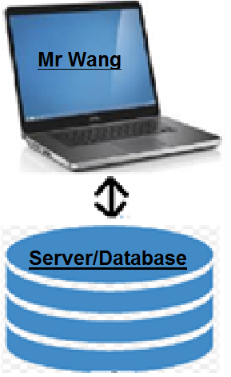
Since Mr Wang has mentioned that he is installing the software and using it on a single computer, the diagram would look like this as shown above- where Mr Wang’s computer, is the “client” and his database being the “server” is exchanging data and requests, to and from.
With a 2-tier system architecture, Mr Wang would be able to enjoy advantages such as:
- Easy modification of the system when necessary
- Easy maintenance of the system
- Fast communication (Since communication is direct)
- Cheaper cost of implementation

It is known that in 2-tier system architecture, performance will decrease upon increasing the number of users, however, since there is only one user- the reception staff, Mr Wang would not have to worry about jeopardized performance of the system.

Lastly, it is known that connections to the database servers can be expensive and cost-inefficient since many of the users only use their connections 2-3% of the time, but since Mr Wang has expressed his future plans to accommodate more functionalities and features such as allowing for online guests to inquire about room availability online entirely, Mr Wang can consider this as a future investment.

USER INTERFACE (UI) DESIGN

After much discussion and consideration, our team had decided to produce a web form that can be access within the hotel using only the hotel’s intranet, due to security & confidential purposes

While working on the design interface of the web form, we consider certain factors such as; consistency, simplicity, contrast & color, and white spaces.

Consistency: We design it in a way that the users could navigate between pages easily using the navigation sidebar (located at the left-hand side of every page). Secondly, all reports would have a print preview button located at every right-bottom side of the report. Thirdly, Search button, filters, or date are located at the top right-corner (if there is any) so that the user could again easily locate and perform certain functions with it. With this, we aim to make our users love the software that we are producing.

Simplicity: Rooms are displayed in the floor map of the hotel for the user to easily select and view the available rooms in a simplified way. Staff details are listed in a grid view format with a photo of each staff member for the user to easily find their desired staff, instead of having to click one-by-one to find the right staff. This would eliminate frustration on searching for a particular staff, as well as to keeping the design simple for the user.

Contrast & Color: We chosen five color that are not dependent on each other to enhance the viewing of the User Interface (UI). The colors are red, green, blue, grey and milky white. With these five-different obvious color, it differentiates the screen for the users and reduces the level of eye straining. (Images are attach at the bottom of the document)

White Spaces: The web form would have some empty spaces in various pages to redirect user’s attention on to the important features in that page, rather than having a design that are squeezed and clustered together which can confuse the user of the main purpose of the page.

Mock-up Screen

Home Page

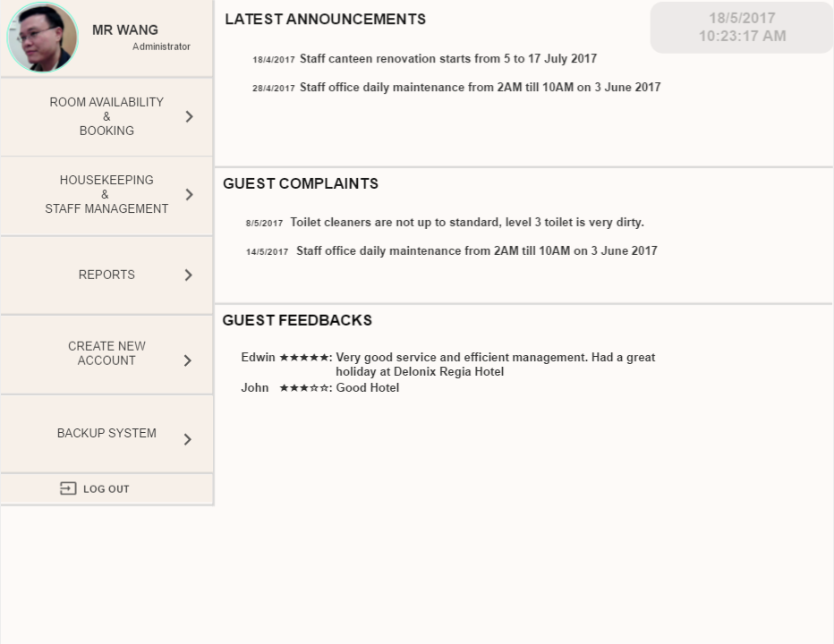
Clickable to return to home page
Click to navigate to individual content

Room Availability Page

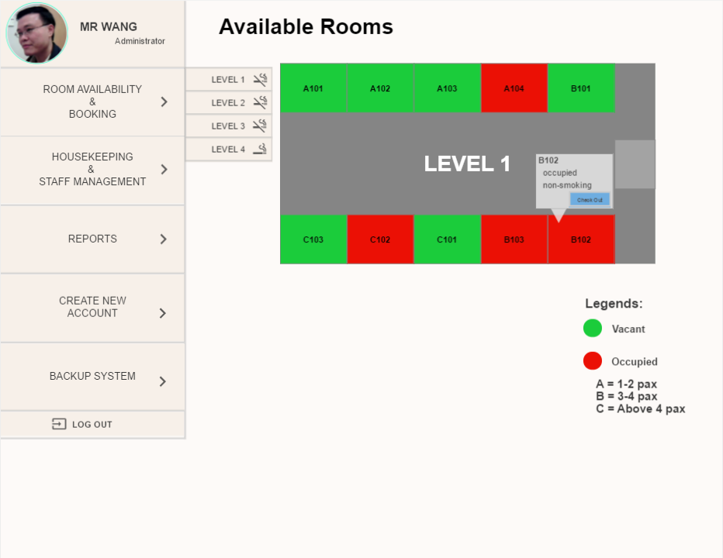
Click to navigate to individual levels
Floor-Map

Hover over for room details.
(includes Check in or check out buttons)

Customer Details Page

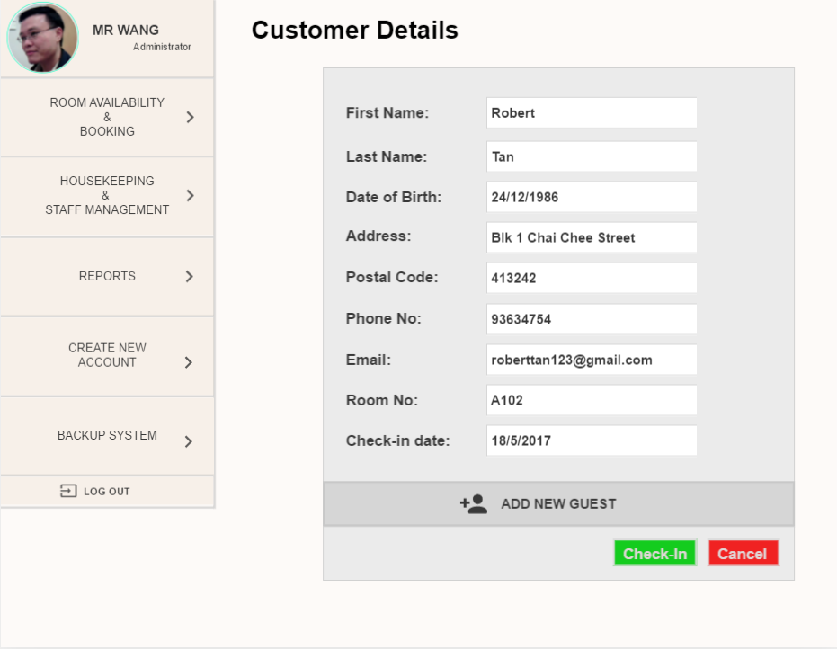
Clickable to add new guest
Fields to be filled up (Data required), else error message will be shown

Customer’s Details Page

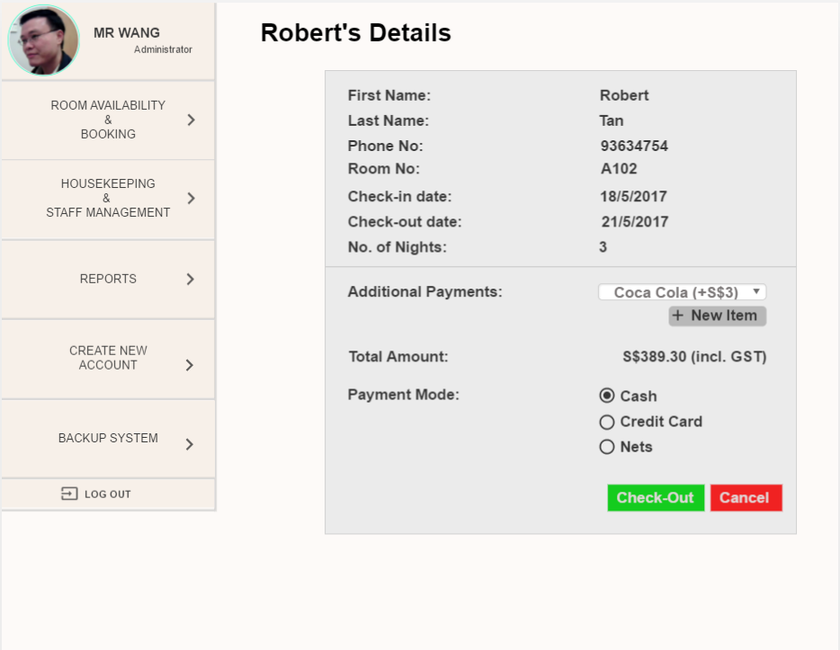
Radio button to choose the payment mode
Dropdown list to show what to be added,
Clickable (+ New Item) to add additional item

Staff Details Page

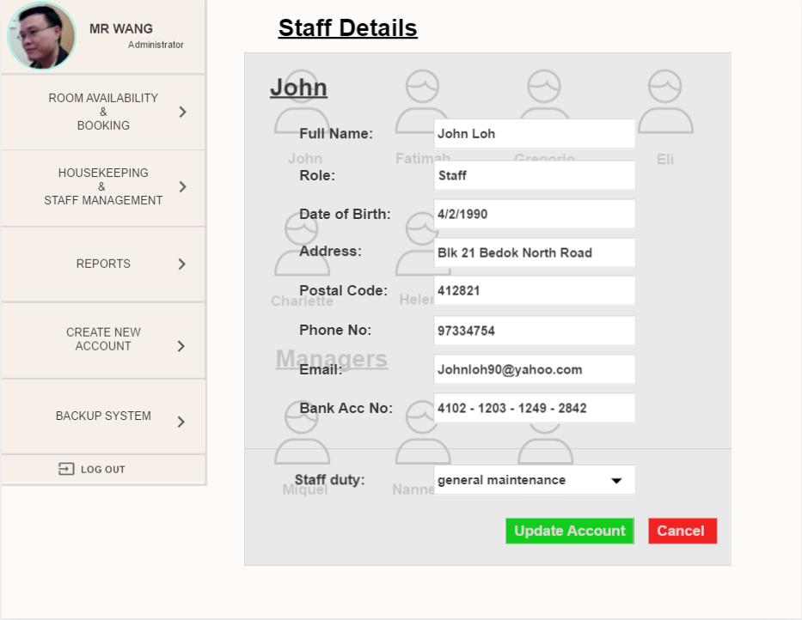
Clickable Photo of staff to pop up the staff’s details
Clickable to choose staff duty,
Dropdown list will show what duty types are available
This is a popup when the staff photo is clicked. Staff details will be shown
Fields to be filled up (if any),
Data required, else error message will be shown.

*Note: All reports subjective to hotel report format.
Room Status Report Page
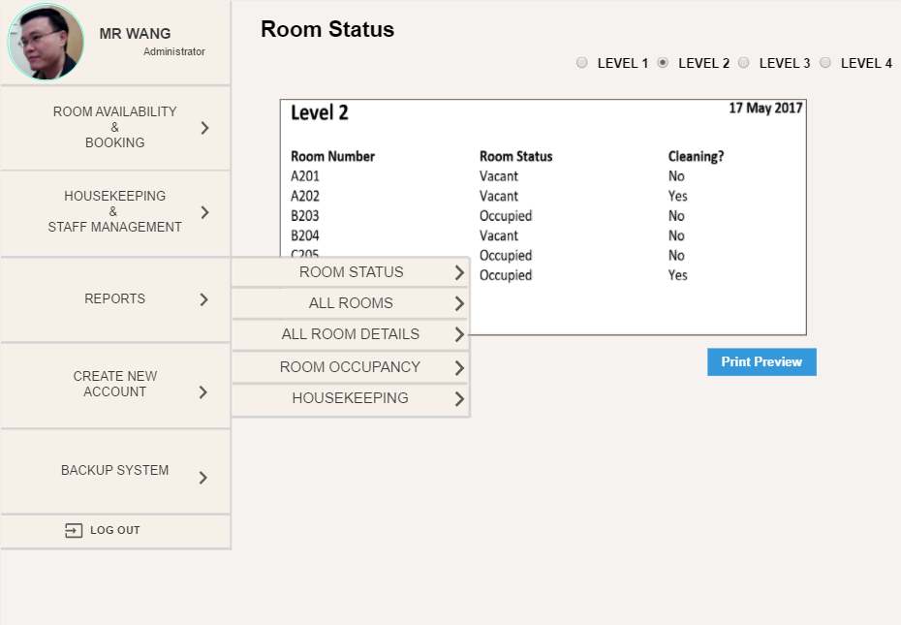
Click to navigate to individual reports
Radio button to select the desired floor level,
Once selected, a report will be shown pertaining to the level
This is the report, Reports* can be previewed first before printing.

All Rooms Page
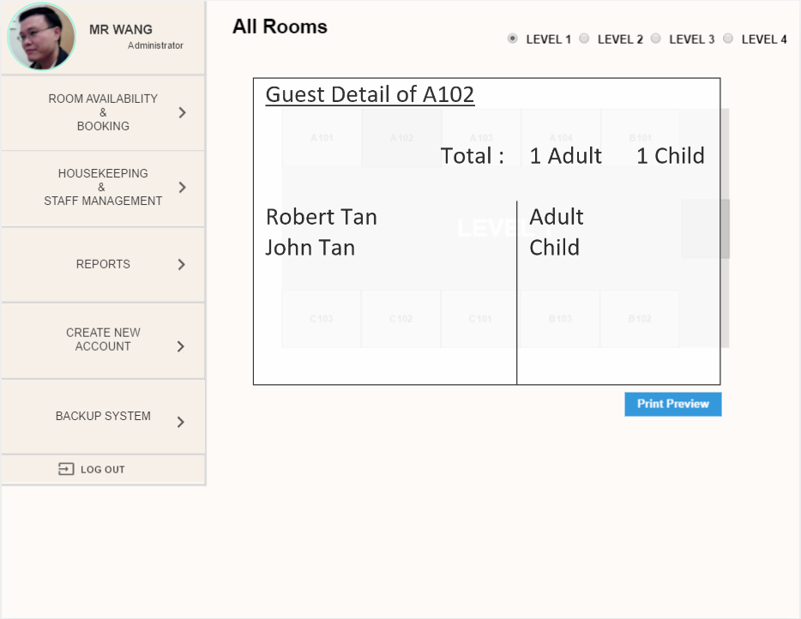
Radio button to select the desired floor level,
Once selected, it will display the floor map of the level
This is the report, Reports* can be previewed first before printing.
Floor-Map. Upon selecting the room, it will display all occupants in that room

All Rooms Detail Page

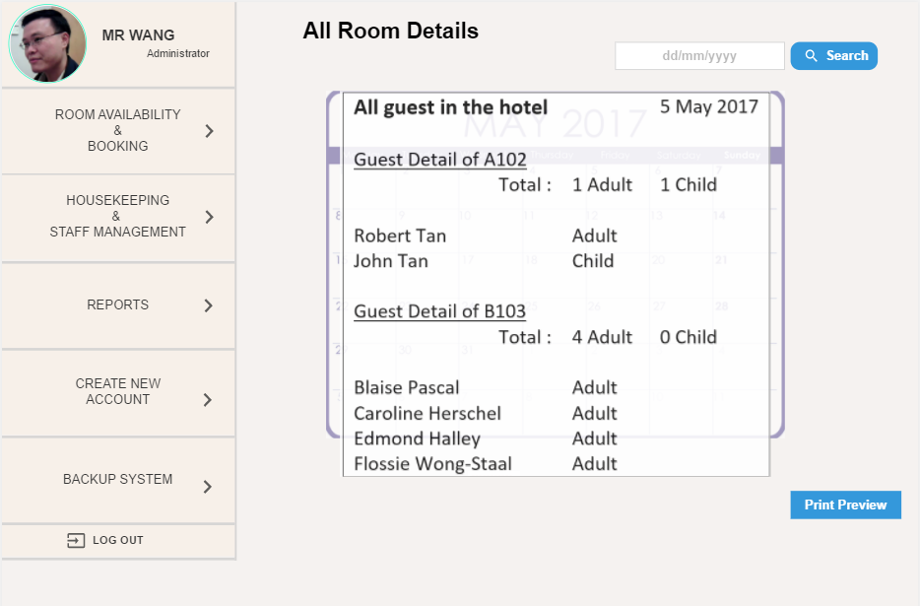
Search field & button to search the desired date
Calendar. Upon selecting the date, it will display all occupants in all the rooms

This is the report, Reports* can be preview first before printing.

Room Occupancy Page
Search field & button to search the desire date
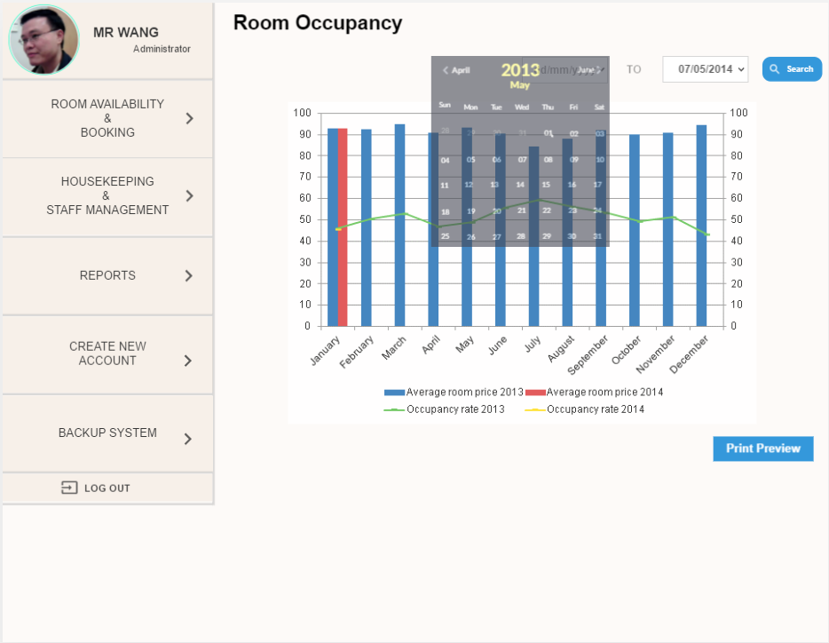
This is the statistics report, Reports* can be preview first before printing.
Popup calendar to choose the date by daily, weekly, monthly, and yearly. For quicker and exact search of date

Housekeeping Page
Search field to search the desired Name, Type or Allocation prior to the staff
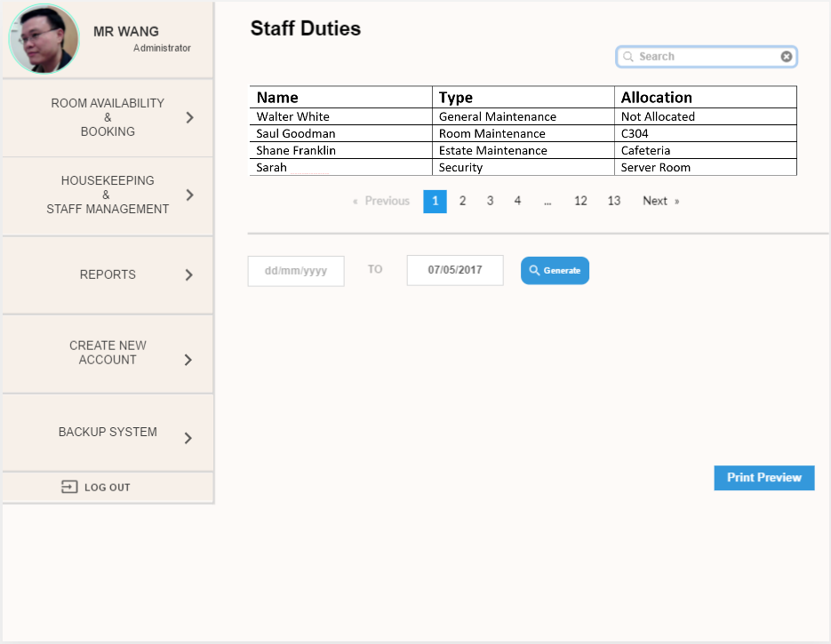
This is the report, Reports* can be previewed first before printing.
Search desired length of date to generate the schedule.
Able to choose the date by daily, weekly, and monthly.

Create New Account Page

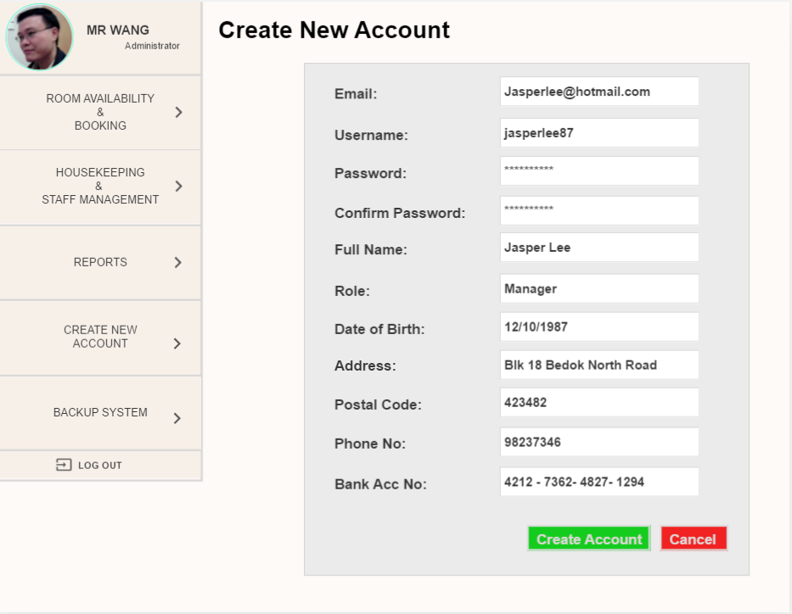
Fields to be filled up (Data required), else error message will be shown

Popup calendar
Backup Page

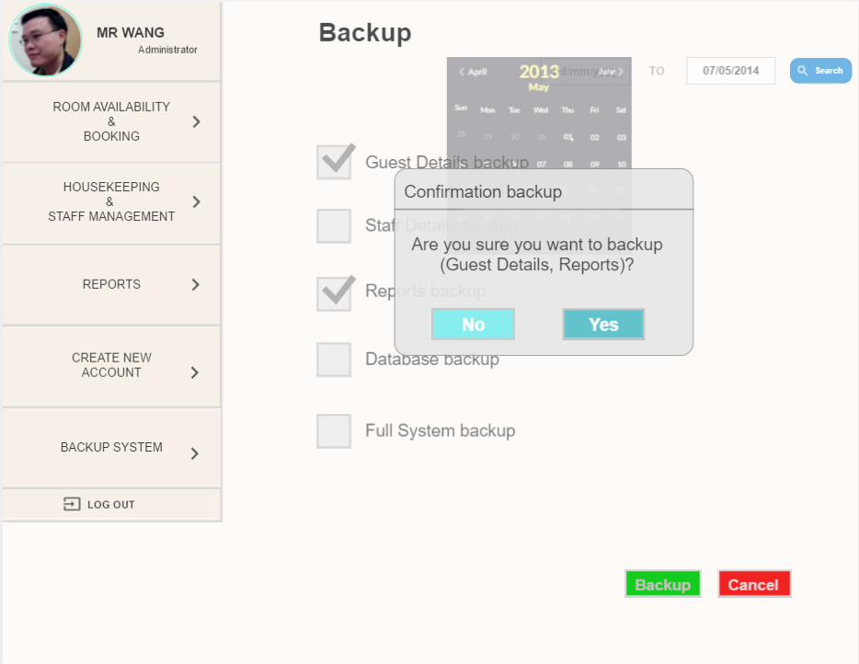
Search desired length of date to backup
Check box, for selection on what to be backed up
Popup confirmation after clicking on Backup Button

PROGRAM DESIGN
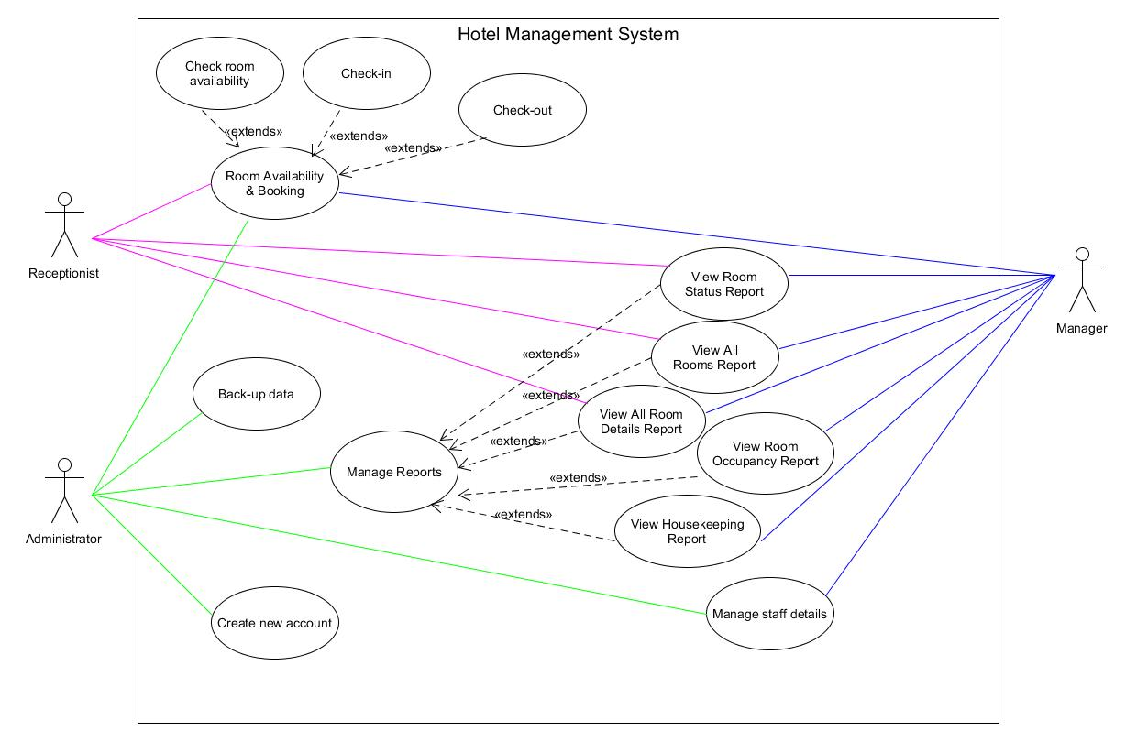

DATABASE DESIGN

Database Schema

Guest (G_ID, G_First_Name, G_Last_Name, G_DOB, G_Address, G_Postal_Code, G_Phone_No, G_Email*)

Booking (B_ID, B_Check_In, B_Check_Out, B_Booking_Date, B_No_of_Nights, G_ID)

Room_Booking (B_ID, R_ID)

Room (R_ID, R_No, R_Type, R_ Rates, R_Status)

Payment (P_ID, P_Total_Amt, P_Type, P_Add_Payments, P_Payment_Status, P_Remarks*, P_Early_Check_In*, P_Late_Check_Out*, B_ID)

Payment_Details (PD_ID, PD_Card_No*, PD_Holder_Name*, PD_Expire_Date*, P_ID)

Staff (S_ID, S_Name, S_Role, S_DOB, S_Bank_Acc_No, S_Address, S_Postal_Code, S_Phone_No, S_Email*)

Staff_Duty (SD_ID, SD_Type, SD_Date, S_ID, R_ID)

Entity Relationship Diagram (ERD)

Makes
LEGENDS:
# Unique Identifiers
* Mandatory Attributes
o Optional Attributes

Allocates
Allocated to
Maintain by
Maintain
Performed by
Performs
Staff
# S_ID
* S_Name
* S_Role
* S_DOB
* S_Bank_Acc_No
* S_Address
* S_Postal_Code
* S_Phone_No
o S_Email

Staff_Duty
# SD_ID
* SD_Type
* SD_Date

Room Booking

Room
# R_ID
* R_No
* R_Type
* R_Rates
* R_Status

Consist
Consist of
Assigned to
Assigned by
Payment_Details
# PD_ID
o PD_Card_No
o PD_Holder_Name
o PD_Expire_Date

Paid by
Pays
Made By
Guest
# G_ID
* G_First_Name
* G_Last_Name
* G_DOB
* G_Address
* G_Postal_Code
* G_Phone_No
o G_Email
Booking
# B_ID
* B_Check_In
* B_Check_Out
* B_Booking_Date
* B_No_of_Nights

Payment
# P_ID
* P_Total_Amt
* P_Type
* P_Add_Payments
* P_Payment_Status
o P_Remarks
o P_Early_Check_In
o P_Late_Check_Out

Database Dictionary

Table Name: Guest

Table Column Name | Table Column Datatype | Table Column Null Option | Table Column Comment | Table Column is PK | Table Column is FK
G_ID | INTEGER (10) | NOT NULL |  | Yes | No
G_First_Name | VARCHAR (35) | NOT NULL |  | No | No
G_Last_Name | VARCHAR (35) | NOT NULL |  | No | No
G_DOB | DATE | NOT NULL | Date of birth | No | No
G_Address | VARCHAR (100) | NOT NULL |  | No | No
G_Postal_Code | CHAR (6) | NOT NULL |  | No | No
G_Phone_No | INTEGER (15) | NOT NULL |  | No | No
G_Email | VARCHAR (80) | NULL |  | No | No

Table Name: Booking

Table Column Name | Table Column Datatype | Table Column Null Option | Table Column Comment | Table Column is PK | Table Column is FK
B_ID | INTEGER (10) | NOT NULL |  | Yes | No
B_Check_In | DATE | NOT NULL | The date Guest checks in | No | No
B_Check_Out | DATE | NOT NULL | The date Guest checks out | No | No
B_Booking_Date | DATE | NOT NULL | The date Guest books the hotel | No | No
B_No_of_Nights | INTEGER (5) | NOT NULL |  | No | No
G_ID | INTEGER (10) | NOT NULL |  | No | Yes

Table Name: Room_Booking

Table Column Name | Table Column Datatype | Table Column Null Option | Table Column Comment | Table Column is PK | Table Column is FK
B_ID | INTEGER (10) | NOT NULL |  | Yes | Yes
R_ID | INTEGER (10) | NOT NULL |  | Yes | Yes

Table Name: Room

Table Column Name | Table Column Datatype | Table Column Null Option | Table Column Comment | Table Column is PK | Table Column is FK
R_ID | INTEGER (10) | NOT NULL |  | Yes | No
R_No | CHAR (5) | NOT NULL | Room number (e.g. A103) | No | No
R_Type | VARCHAR (80) | NOT NULL | Single Room, Double Room, etc. | No | No
R_Rates | DECIMAL (5,2) | NOT NULL | Amount charged per room | No | No
R_Status | VARCHAR (30) | NOT NULL | vacant, occupied, etc. | No | No

Table Name: Payment

Table Column Name | Table Column Datatype | Table Column Null Option | Table Column Comment | Table Column is PK | Table Column is FK
P_ID | INTEGER (10) | NOT NULL |  | Yes | No
P_Total_Amt | DECIMIAL (5,2) | NOT NULL |  | No | No
P_Type | VARCHAR (30) | NOT NULL | Cash, credit card, debit card, etc. | No | No
P_Add_Payments | DECIMIAL (5,2) | NOT NULL | Additional payments for the items taken in the mini bar | No | No
P_Payment_Status | BOOLEAN | NOT NULL | Only accept TRUE (paid) or FALSE (have not pay) | No | No
P_Remarks | VARCHAR (100) | NULL | Additional request from the Guest (e.g. King size bed) | No | No
P_Early_Check_In | Date | NULL
P_Late_Check_Out | Date | NULL |  | No | No
B_ID | INTEGER (10) | NOT NULL |  | No | Yes

Table Name: Payment_Details

Table Column Name | Table Column Datatype | Table Column Null Option | Table Column Comment | Table Column is PK | Table Column is FK
PD_ID | INTEGER (10) | NOT NULL |  | Yes | No
PD_Card_No | INTEGER (20) | NULL | Leave empty if guest is paying by cash | No | No
PD_Holder_Name | VARCHAR (80) | NULL | Leave empty if guest is paying by cash | No | No
PD_Expire_Date | DATE | NULL | Leave empty if guest is paying by cash | No | No
P_ID | INTEGER (10) | NOT NULL |  | No | Yes

Table Name: Staff

Table Column Name | Table Column Datatype | Table Column Null Option | Table Column Comment | Table Column is PK | Table Column is FK
S_ID | INTEGER (10) | NOT NULL |  | Yes | No
S_Name | VARCHAR (70) | NOT NULL | Staff full name | No | No
S_Role | VARCHAR (20) | NOT NULL | Administrator, Staff, Manager | No | No
S_DOB | DATE | NOT NULL | Date of birth | No | No
S_Bank_Acc_No | INTEGER (20) | NOT NULL |  | No | No
S_Address | VARCHAR (100) | NOT NULL |  | No | No
S_Postal_Code | CHAR (6) | NOT NULL |  | No | No
S_Phone_No | INTEGER (15) | NOT NULL |  | No | No
S_Email | VARCHAR (80) | NULL |  | No | No

Table Name: Staff_Duty

Table Column Name | Table Column Datatype | Table Column Null Option | Table Column Comment | Table Column is PK | Table Column is FK
SD_ID | INTEGER (10) | NOT NULL |  | Yes | No
SD_Type | VARCHAR (30) | NOT NULL | general maintenance, room maintenance, estate maintenance and security | No | No
SD_Date | DATE | NOT NULL | The date staff performs their staff duties | No | No
S_ID | INTEGER (10) | NOT NULL |  | No | Yes
R_ID | INTEGER (10) | NOT NULL |  | No | Yes

- REFERENCES

Two-Tier Architecture. (n.d.). Retrieved from https://www.techopedia.com/definition/467/two-tier-architecture

